**CURRICULUM VITAE**

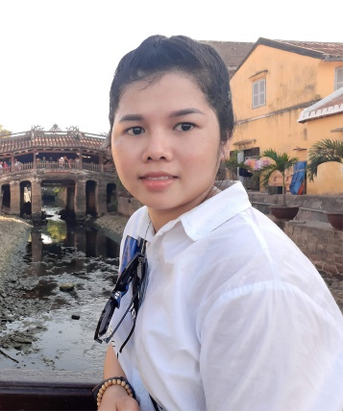Full name: Bùi Thị Vân

Gender: Female

Date of Birth: 10-10-1993

Marital Status: Single

Address: 248/33/13 Nguyen Thai Binh, Tan Binh District, HCM

Cell Phone: 0979814134

Email: [van.bt.38@gmail.com](mailto:van.bt.38@gmail.com)

Website: <http://vanbui.info/>

**INTRODUCTION**

With over 05 years’ experience in environments as Front-end, e-commerce website, for the companies that I have worked, I'm confident always trusted and appreciated by the superior for create, work hard to devote to the company.  
I'm also good at communicating with everyone so if I have the opportunity to work at your company I believe that I will be an excellent employee too.  
I hope to have a chance to present in more detail, if the company chooses to interview me.

**EDUCATION**

I graduated from **Ho Chi Minh City Industry And Trade College** (2011-2014)

My major is **Computer Science** (2011-2014): Good

**SKILLS**

* **Programming languages:** HTML5, CSS3, Javascripts, jQuery, Bootstrap, Liquid, ReactJS, Redux, Redux-thunk, Redux-saga, Axios, Sass /Scss, material UI, redux-form.
* Database: Firebase, PostgreSQL, MySQL
* Experience with GIT
* Can understand ES2015 ( ES6).
* Order skills: Photoshop
* Ability to learn new technology quickly
* Work under hight pressure
* I have experience in e-commerce platform with Liquid (Haravan, Shopify)
* Experience with website responsive, SEO Technical & mobile friendly
* Languages: Conversational Japanese – N3 JLPT, English basic skills

**EXPERIENCE RECORD**

**From 06-2017 To Present: Transcosmos Viet Nam**

* Position: Web developer
* Descriptions: Developing websites' layouts for Japanese clients.

During this time I also made many websites of big Japanese clients such as  
Hoya contact lens- https://www.eyecity.jp/, Suntory-https://suntoryflowers.blog.suntory.co.jp/,  
https://www.linebiz.com/jp/, https://www.toyobo.co.jp/ , …  
Also, while I was working for this company, I was appointed to go for a business  
trip at the Head Quarter of the company in Tokyo, Japan for the period of three  
months

**From 09-2014 To 06-2017: Haravan.com**

* Position: Technical Support
* Descriptions:
* Responsible for building, organizing work for team.
* Get feedback from clients and convey to producer
* Training on the system and code (Liquid) for new members.

During that time I also support many big Vietnamese clients such as :  
Vinamilk - https://giacmosuaviet.com.vn/ , https://thefaceshop.com.vn/, http://juno.vn/,  
https://www.thecoffeehouse.com/,Aeon Eshop - https://aeoneshop.com/, iBasic -  
https://ibasicvietnam.com/, http://aothun.vn/ , https://shop.epomi.com/,  
https://watchworld.vn/...  
Also I had experience working with partners such as giaohangnhanh, viettel  
post, giaohangtietkiem, kiotviet, suno.vn...

**From 04-2014 To 07-2014**  **: Phuong Nam Informatics Center**

* Position: Assistant professor
* Descriptions:  Support or provided guidance skills to learners at IT center  
  (Word, Excel, Powerpoint, Access)

**CERTIFICATES, AWARDS**

**2013:** Ho Chi Minh City Industry and Trade College Prize

**2015 -** Haravan Company**:** The Employee Excellence Award

**2017 -** Haravan Company**:** Dedication Award

**2018 -** Transcosmos Company**:** Business Improvement Award

**2018 -** Transcosmos Company**:** Revenue Development Award

**CAREER EXPECTATION**

**What is my career objective?**

Try to learn as much as possible and doing my best in order to accomplish my task

I want to improve my skills according to company’s development

Fluent my English to serve my work

**INTERESTED**

Listening to the music, reading newspaper, travelling, watching film, cooking, grow flower

Enjoy the yoga, camping, picnic